Synopsis

Sentiment Analysis of Product Reviews using Machine Learning

Problem Id: 16

Student Name : Dhanvi Sarpal
University Roll number: 2025708
Section: G

Student name :Garima Gupta
University Roll No.: 2029409
Section: G

Student Name : Ruhani Aneja
University Roll no.: 2028828
Section :G

- Problem Description:
Sentiment analysis is the process of identifying the emotional tone behind a piece of text. In this project, we aim to develop a machine learning model that classifies product reviews into positive, negative, or neutral categories. With the rapid growth of e-commerce platforms, customers rely heavily on reviews before purchasing products. However, manually analyzing thousands of reviews is time-consuming and inefficient.
This project automates the process by using natural language processing (NLP) and machine learning techniques to extract meaningful insights from textual data. The system preprocesses the text, converts it into numerical features, and applies classification algorithms to predict sentiment. This helps businesses understand customer feedback, improve product quality, and enhance customer satisfaction. The project has real-life applications in online shopping platforms, social media monitoring, and customer service systems.
- Steps of Implementation:
1. Dataset Selection & Preparation
• A dataset containing product reviews (dataset_reviews.csv) is selected.
• The raw data is cleaned by stripping whitespace from column names and converting them to lowercase.
• Sentiment Mapping: A custom function converts numerical ratings into categories: Positive (Rating \bm{\ge} 4), Neutral (Rating = 3), and Negative (Rating < 3).
2. Exploratory Data Analysis (EDA)
• Statistical and visual analysis is performed to understand the data distribution.
• Visualizations: Includes histograms for rating distribution, bar charts for "Like vs. Dislike" counts, and pie charts for "App Source" distribution.
3. Data Preprocessing
• Noise Removal: Using Regular Expressions (re.sub) to remove special characters and numbers.
• Lowercasing: Converting all text to lowercase for consistency.
• Feature Engineering: Calculating review_length based on word counts.
• Tokenization: Splitting sentences into individual word tokens.
• Stopword Removal: Eliminating non-essential words using the NLTK library.
• Lemmatization: Utilizing WordNetLemmatizer to convert words into their base meaningful form.
4. Feature Extraction
• Text data is converted into numerical form using TF-IDF Vectorization.
• The vectorizer is configured with max_features=5000 and ngram_range=(1,2) to capture both single words and common phrases.
5. Train-Test Split
• The dataset is divided into training (80%) and testing (20%) sets.
• Stratification: Stratified sampling is used to maintain the balance of sentiment classes in both sets.
6. Model Training
• Logistic Regression (LR): Optimized with max_iter=1000.
• K-Nearest Neighbors (KNN): Implemented with 5 neighbors and a Cosine Similarity metric.
• Support Vector Machine (SVM): Utilizing a linear kernel with probability estimates enabled.
7. Model Evaluation
• Performance Metrics: Accuracy, Precision, Recall, and F1-Score.
• Advanced Evaluation:
• Confusion Matrix: Heatmaps generated via Seaborn to visualize correct vs. incorrect predictions.
• ROC/AUC Curve: Analyzing the True Positive Rate against the False Positive Rate for the "Positive" class.
The models are compared based on their weighted F1-Scores to determine the most suitable algorithm..
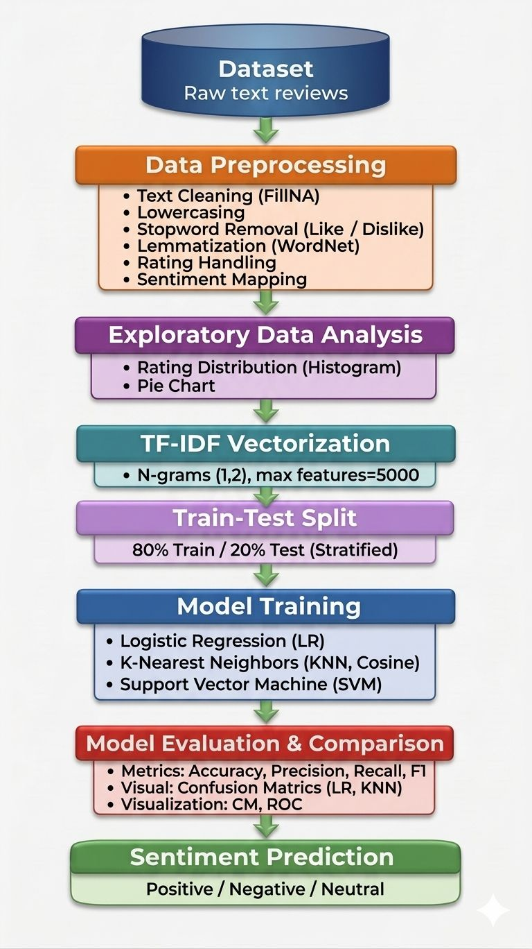
- 3. Expected Modules / Libraries to be used
• Pandas: For data manipulation and mapping.
• NumPy: For numerical operations and handling NaN values.
• NLTK: For tokenization, stopwords, and lemmatization.
• Scikit-learn: For TF-IDF, model training, and evaluation metrics.
• Re: For text cleaning via Regular Expressions.
• Matplotlib & Seaborn: For plotting distributions, pie charts, and confusion matrices.

- 4. Required Topics from the Subject
• Strings: Used for manipulating textual review data.
• Files: Used to read CSV datasets.
• Functions: Used to modularize the sentiment conversion and text cleaning processes.
• Data Structures: Using Pandas DataFrames and Series for efficient data storage.

- Platform Required:

Google Colab / Jupyter Notebook

- Books and Link Sources:
1.“Python for Data Analysis” by Wes McKinney
2. GeeksforGeeks (https://www.geeksforgeeks.org)
3. Scikit-learn official documentation
4. Kaggle datasets (https://www.kaggle.com)

